**EXPERIMENT NO. 6**

**AIM:** To perform Histogram Stretching on an image.

# **THEORY**:

It is a method to increase the dynamic range of the image. Here we do not alter the basic shape of the histogram, but we spread it so as to cover the entire dynamic range. We do this by using a straight line equation having a slope

(smax – smin)/ (rmax - rmin)



smax = Maximum grey level of output image

smin = Minimum grey level of output image.

rmax = Maximum grey level of input image

rmin = Minimum grey level of input image.



This transformation stretches and shifts the grey level range of input image to occupy the entire dynamic range (smax , smin).

**Problem Definition:**

1. Take a color image of size MxN
2. Convert Color image to Gray Scale Image
3. Apply Stretching transformation
4. Plot the input image, its histogram, output image and its histogram
5. Conclude by specifying the applications where histogram stretching can be used

**CODE**:



| Iimg=imread('pout.tif'); subplot(2,2,1) imshow(Iimg); title('Original image'); subplot(2,2,2) imhist(Iimg); title('Original Histogram'); rmin = min(min(Iimg)); rmax = max(max(Iimg)); smin = 0; smax = 255; y=(((smax-smin)/(rmax-rmin))*(Iimg-rmin))+smin; subplot(2,2,3) imshow(y); title('Stretched Image'); subplot(2,2,4) imhist(y); title('Stretched Histogram'); |
| --- |

**OUTPUT**:

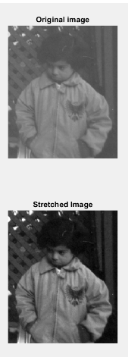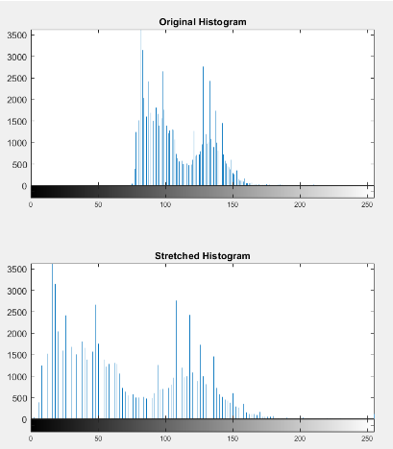

**CONCLUSION**:

Histogram stretching is one of the best methods to improve contrast in an image using MATLAB. In this experiment, we have done image processing on ‘pouf.tif’ image and have displayed the histogram before and after stretching.

**Name:** Junaid Altaf Girkar

**SAP ID:** 60004190057

**DIVISION:** BE Comps A2